

**ASSESSMENT: COURSEWORK**

**COLLEGE: Social Science**

**SCHOOL: Psychology**

**MODULE: Research Methods in Psychology**

**MODULE CODE: PSY9251M/PSY9219M**

**LEVEL: Masters**

**SEMESTER: A**

**CO-ORDINATOR: Tochukwu Onwuegbusi**

**ASSESSMENT TYPE: Take-home assignment**

**=========================================================**

**INSTRUCTIONS TO STUDENTS**

**Question to Answer: See attached**

**Date for Submission: 22/02/21**

**Submission mode: Assignments must be submitted via Turnitin (under**

**‘Assessment Submission’ on Blackboard)**

**Instructions for submission**

The answers to the four questions and any appendices should be presented in **one Word document** and should be submitted via Turnitin. The relevant R results should be integrated within the text.

* **Note 1**: For questions 1 and 2, default R output is acceptable, accompanied by plain text explanation of the results; where “tables” are requested, data.frames or tibbles are acceptable. For question 3, the results of statistical tests should be reported in APA 7 format where possible.
* **Note 2**: In the questions below, specific packages to be used are indicated using **bold** type. Specific functions are indicated in ***bold italics***and will always be followed by brackets - e.g. ***data.frame()***
* **Note 3:** To answer the questions, you may use any packages and functions that you like, except where explicitly specified. Please check Blackboard for up-to-date advice on which packages you will need to have installed, but you will **at minimum require** the following packages to be installed and loaded for some questions:
  + **tidyverse** (note that this installs several packages, including **ggplot2**)
  + **performance**
  + **afex**
  + **emmeans**
  + **see**

**ENTER YOUR EXAM ID AS THE TITLE OF YOUR ASSESSMENT.**

**Word-count:**

Question 1: approx. 250 words (no hard maximum)

Question 2: approx. 750 words (no hard maximum; excluding figures/charts)

Question 3: maximum 1250 words (excluding figures/charts)

Question 4: maximum 1250 words

**Formatting instructions**

Please follow the APA guidance on academic writing when formatting your assessment. The guidance can be accessed via this link: <https://guides.library.lincoln.ac.uk/c.php?g=683973&p=5007792> Guidance on writing in APA style - APA 7th Edition - University of Lincoln - Guides at University of Lincoln

**Assessment criteria for Questions 1-3**

* Good work will show a good understanding of the relationship between research question(s) and the choice of statistical test(s).
* Good work will show competence in the interpretation of statistical test results.
* Note that where R code is requested, you will be marked on the *correctness* but not the *style* of the code. It is important that the code produces the correct results, not that the code matches how it would be written by somebody else.
* Good work will be clearly and neatly presented.
* For question 1, R code should be supplied where requested but **SHOULD NOT** be written inside code chunks. Simply write the code as plain text.
* For question 2, R code and output should be provided.
* Students are reminded that the assessment must be produced **independently**. Please refer to University policy on academic offences. This can be found within the Assessment folder on the module Bb site.

**Assessment Criteria Question 4**

We are looking for you to demonstrate advanced academic skills in this assessment, as are appropriate to Masters Level. These include the ability to:

* Demonstrate an advanced and nuanced understanding of a range of methods for analysing qualitative data.
* Select and integrate relevant knowledge to produce a coherent answer.
* Appreciate, critically evaluate and critically contrast competing solutions to a problem.
* Apply knowledge to the specific phenomena in question (i.e. generalised, off-the-shelf evaluations of any given method will gain only limited marks).
* Take a critically comparative approach – considering the advantages and disadvantages of different solutions in contrast to alternative solutions (i.e. treating each alternative independently of one another will gain only limited marks).
* Produce work that is clearly written with correct spelling, grammar and punctuation.
* Students are reminded that the assessment must be produced independently.

**Please note that this assignment will be sent to MASH. Students should not consult MASH for help with the assignment.**

**Question 1 (9 marks)**

NOTE: for this question, where code is requested, it is sufficient to provide it as plain text. Do NOT write it in code chunks.

1a. How would you load the **performance** package? Assume that the package is already installed. **1 mark**

1b. Write the code required to load the package and the command that you would you need to use to load the file `assessment_information.xlsx` into R and assign it to an object called **assessment_information**. **2 marks**

1c. In the command **lm(weight ~ height, data = BMI)**, which variable is the dependent variable and which is the independent variable? **1 mark**

1d. Replace each instance of the word NULL in the following ***ggplot()*** call to recreate the figure shown below, which was produced from the **crime_replication** dataset provided for this assignment. **4 marks**

ggplot(data = NULL, aes(x = NULL, y = NULL)) +

geom_NULL()

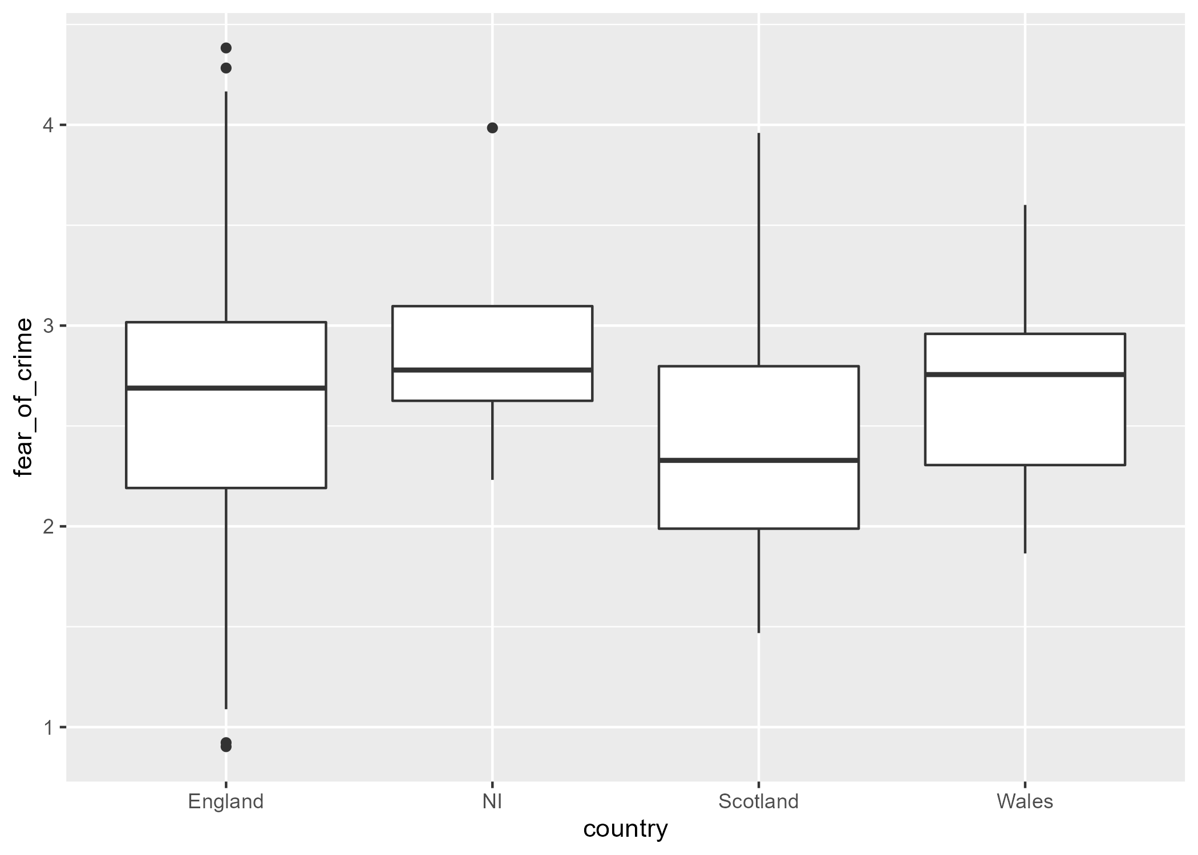

1e. Write out an appropriate command that would keep only rows in the **“crime_replication”** datawhere participants were under the age of 20 and had not been a victim of crime. **1 mark**

**The Fear of Crime replication study**

**Question 2 (30 marks)**

**Study description**

Your supervisor performed a partial replication of the Fear of Crime study by Ellis & Renouf (2018). The original study examined how a variety of different measures of personality might be predictive of how fearful of crime a given person might be. An issue that your supervisor noted with the original study was that the sample was quite imbalanced with respect to the two primary categorical variables – sex and whether the participant had been a victim of crime. Thus, your supervisor made a concerted effort to recruit a better balanced sample with respect to these variables.

For their version of the study, your supervisor focussed on the effects of anxiety on fear of crime. Each participant completed a questionnaire regarding their fear of crime and the State-Trait Anxiety questionnaire, which provides measures of 1) how anxious a person feels at the time of completing the questionnaire (“State anxiety”) and 2) how anxious a person is in general (“Trait anxiety”). The resulting dataset is available in .csv format. The data should be loaded using the ***read_csv()*** function from the **readr** package.

**2a. Basic descriptive statistics (8 marks)**

Your supervisor wants you to perform some statistical analysis and exploration of the data. They have a couple of requests for some simple summary statistics and visualizations of the data.

1. They want to check:
   1. how many men and women were and were not victims of crime
   2. the average level of fear of crime for each combination of the two categorical variables
   3. how much variability there is in fear of crime for each combination of the two categorical variables.

At this stage, your supervisor only wants to see these key pieces of information; no statistical tests are required. Produce a single basic summary table that provides the information that your supervisor requested. Ensure that you choose appropriate summary statistics for each element. **3 marks**

1. Your supervisor’s second request is to be able to see how fear of crime is distributed in the data across the different groups. Using **ggplot2**, provide a figure allowing visual comparison of the distribution of fear of crime scores for each combination of the two categorical variables – “sex” and crime victim”. **5 marks**

**2b. Correlation and regression (12 marks)**

Your supervisor then asks you to examine the relationships between three of the continuous variables in the data – fear of crime, state anxiety, and trait anxiety.

1. Examine and report the correlations between the three continuous variables fear_of_crime, state_anxiety, and trait_anxiety. **4 marks**
2. Using linear regression, model fear of crime as a function of state anxiety, trait anxiety, or both state and trait anxiety. Compare models to determine which model provides the best fit, and summarise the results accordingly. **8 marks**

**2c. ANOVA (10 marks)**

Finally, your supervisor then asks you to test whether levels of fear of crime differ between male and female participants, and whether this depends on whether they have been a victim of crime or not.

1. Why and how would you address this request using ANOVA? **2 marks**
2. Run the appropriate ANOVA. If post-hoc tests are necessary, perform them. If not, explain why they are not necessary. **4 marks**
3. Check whether the assumptions of ANOVA are met. Explain which statistical tests you are using for this purpose and why. **4 marks**

**Question 3 (27 marks)**

Your supervisor asks you to write a report. This report will be presented and discussed at the annual meeting with the steering committee of the Fear of Crime Project, which consists of academics, police representatives, support counsellors, and of members of a local support group for people who have been victims of crime. To ensure that the findings are clear to all members of the group, you are asked to break this report down into 3 sections. The recommended word-count for each section is included.

Lay summary Project ‘Fear of Crime’: The first section should be a **lay summary** of the aim of the project and the key findings from the statistical tests you have run above. For this section, it is important to consider the potential impact of the findings for the different steering group members and to phrase the findings in a way that is meaningful for all attendees. (approx. 250 words). **5 marks**

Details of statistical results: The second section should be in the style of a typical result section of a peer reviewed journal article. In this section you should consider the academics as your audience. Report the results of all statistical analyses conducted for Question 2, including figures/graphs and tables where you believe that they would be useful. (approx. 750 words). **17 marks**

Limitations and recommendations: In the third section, you can raise key limitations of the chosen design/analyses and recommend/conduct different or additional analyses. (approx. 250 words).

**5 marks**

**Question 4 (34 marks)**

The Fear of Crime study attempts to examine how people’s anxiety impacts their expressed fear of crime, with a particular focus on whether expressed fear of crime reflects current anxiety (i.e. State Anxiety) or long-term (i.e. Trait Anxiety) anxiety, or other personality characteristics (i.e. the HEXACO measures). In addition, the project examines how gender and whether status as a victim of a crime influences reported Fear of Crime. Critically and comparatively evaluate the advantages and disadvantages to investigating people’s fear of crime via the survey method described earlier, as contrasted with taking a qualitative approach to the topic. Ensure that in your answer you include comparison/contrast with:

1. At least 2 qualitative data collection techniques (e.g. interviewing, generated documents, observation, etc.) **17 marks**
2. A Q-Methodology approach **17 marks**